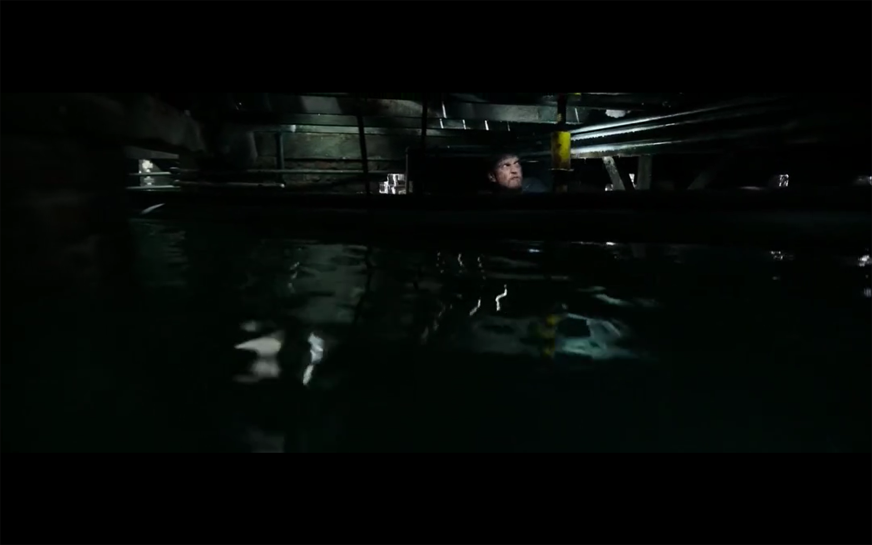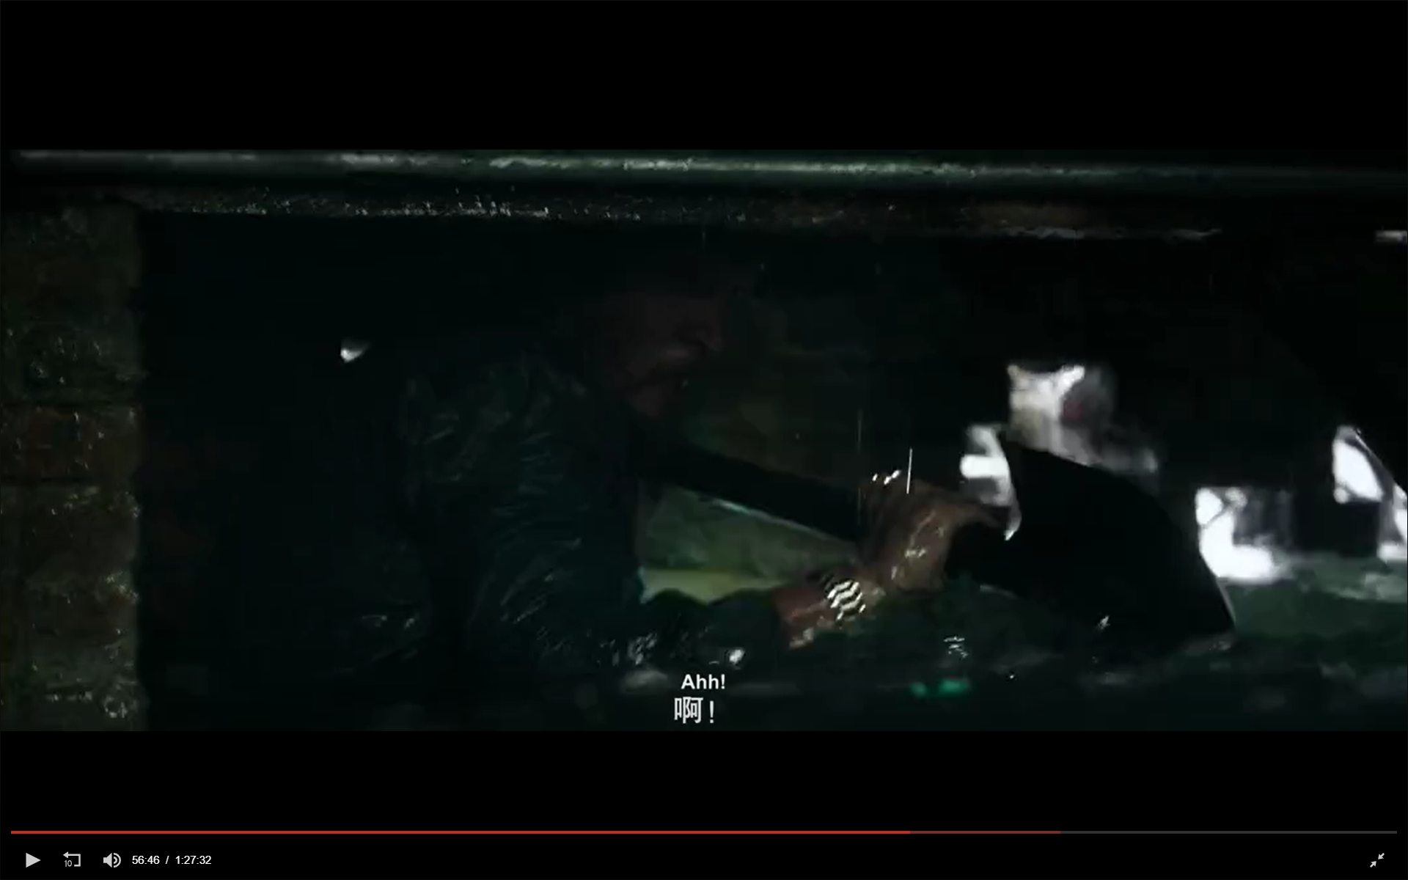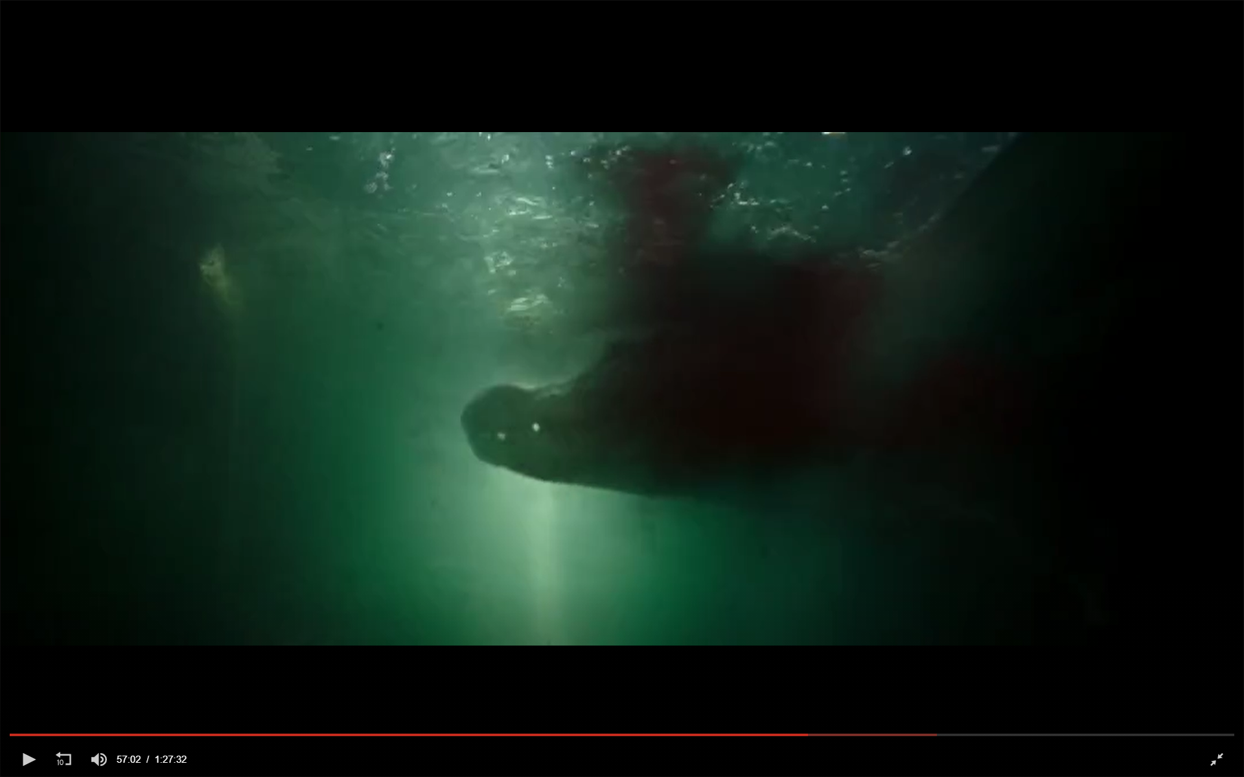M0806908 吳方霽 wu fang-chi

Movie name: Crawl

**Movie Synopsis**:

When the typhoon hit Florida, Hailey went to find her lost father. She found her seriously injured father in the basement of her hometown. The two were also trapped by the soaring flood. Hailey and her father found a crocodile hidden in the water, and then started. Survival battle against crocodiles.

**why you have chosen this movie:**

Because the scene of this movie is rich, there are gradually rising water surface, swimming crocodile, and complicated underground space.

**Scene description**:

The protagonist is trapped in the basement and the water level continues to rise. The crocodile enters the basement due to flooding. The protagonist needs to avoid and attack the crocodile, and finally escape from the basement.

VR adaptation:

1. Can pick up items (EX: bricks, shovel, iron pipe) to attack the crocodile
2. Set obstacles in the basement to increase the difficulty of escape
3. Crocodiles actively attack people
4. 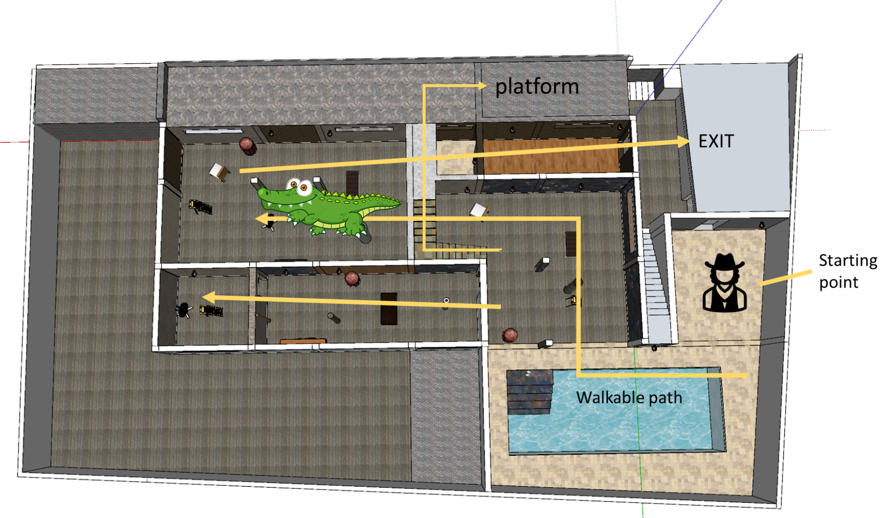Use the oil lamp to guide, the closer to the exit, the brighter the light

In the scene:

1. There is a basement and a platform

2. There are three roads to choose from, which are leading to a closed room, leading to an exit, and a platform for temporary shelter

3. Wall lights are used to guide the exit

4.Cramped basement full of dirty water(Rising water)

5.Crocodile entering the basement due to flooding(Exposed half of the body on the water)

6. Many obstacles prevent people from moving forward

VR technology:

1.picking up items,

2.attacking crocodile,

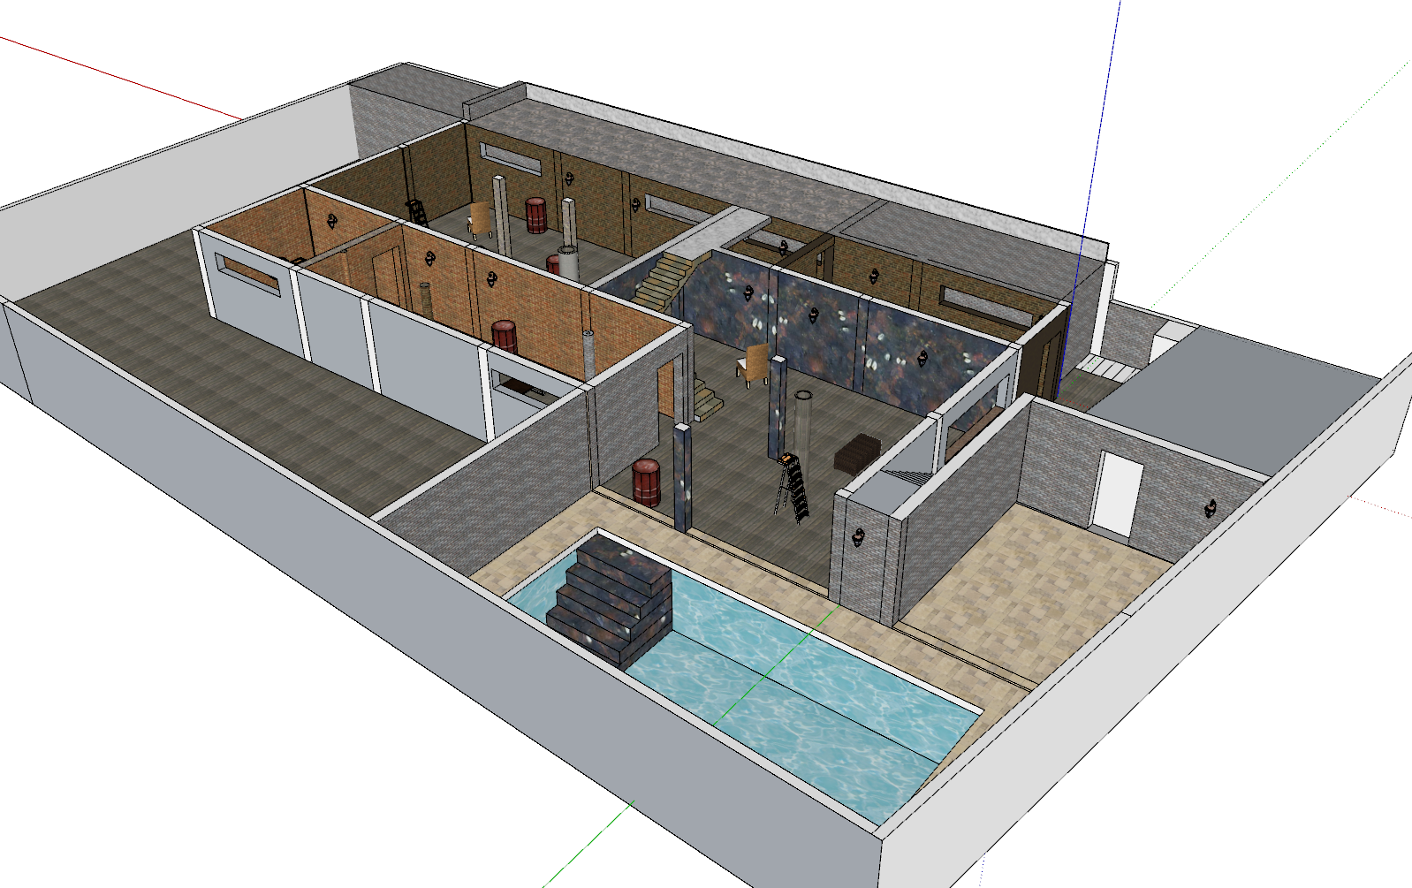3.walking characters